# ****Curriculum Vitae****

**Dr. Hadullo Kennedy Ochilo, PhD**  
PhD in Information Systems (University of Nairobi)  
MSc Information Systems (University of Nairobi)

**Mobile**: +254 722 545 125 | +254 733 770 772  
**Email**: [khadullo@tum.ac.ke](mailto:khadullo@tum.ac.ke) | [khadullo@gmail.com](mailto:khadullo@gmail.com)

## **i. Research Interests**

* Quality Evaluation of E-learning Systems
* Learning Analytics Dashboard Design and Implementation
* Learning Analytics-Supported E-learning
* Machine Learning-Supported E-learning
* Design and Implementation of Web-Based Information Systems

## **ii. Lecturing Experience**

### Teaching Subjects

Web Programming using PHP & Python, Web Development using Django and LARAVEL, C Programming, C++ Programming, Human-Computer Interaction, Mobile Programming, Mobile Application Development.

### **Teaching Experience**

1. **Technical University of Mombasa** — Lecturer (2019–Present)
   * Subjects Taught: Web Programming, Web Development, C/C++ Programming, Human-Computer Interaction, Mobile Computing, Mobile Application Development.
2. **Open University of Kenya** — Software Engineering (February 2025)
3. **Curriculum Development**
   * **May 2020**: MSc in Information Technology curriculum.
     + Achievement: Program launched in 2021; 6 graduates in 2023 (1 supervised to completion).
   * **May 2021**: Developed PhD in Information Technology curriculum.
     + Achievement: First cohort (Jan 2024) currently in second semester.
4. **Mombasa Polytechnic, Kenya** — Senior Graduate Teacher (1997–2009)
   * Subjects: Technical Drawing, AutoCAD, Automotive Engineering.

**iii. Professional Membership of Kenya**

* **Computer Society of Kenya (2018-to date)**

## **iv . Practical Web Software Development Experience**

1. **Technical University of Mombasa (Sep 2020 – Aug 2024)**
   * **Project**: Student Management Information System ([Link](https://smis.tum.ac.ke/))
   * **Role**: Software Development Committee Member
     + Needs assessment
     + System Design & Development
     + System testing & Deployment
     + Staff training
2. **Ministry of Education (Feb 2019 – Aug 2022)**
   * **Project**: TVET Tracer Database ([Link](https://www.education.go.ke/tvet-tracer))
   * **Role**: System Analyst in the project
     + Needs assessment
     + System Design & Development
     + System testing and Deployment
     + Staff training

## **vi. E-Learning Capacity Building**

1. **Open University of Kenya (May 2024)**
   * **Project**: BSc Computer Science – Content Development
   * **Role**: Developed content for CSF 221: Software Engineering
2. **Skills for Prosperity Kenya (May 2021 – Dec 2022)**
   * **Training by**: Open University UK
   * **Key Learnings**:
     + Digital badges, online study prep
     + Social media in learning
     + Facilitating independent learners
     + Digital communication in learning
     + Online teaching principles
     + Activity design for digital contexts
3. **Technical University of Mombasa (Jul – Oct 2020)**
   * **Project**: ODEL Implementation
   * **Role**: Software Project Leader
     + Advised on digital requirements & infrastructure
     + Spearheaded ODEL policy development
     + Trained staff and students
4. **Kenya School of Government, Kabete Campus (2011–2022)**
   * **Role**: E-Learning Trainer
     + Implemented eLearning, ICT & KM programs in public service
     + Developed content and trained trainers (Probation & Aftercare Service, 2021)

## **vii. Academic Qualifications**

|  |  |  |
| --- | --- | --- |
| **Institution** | **Qualification** | **Year** |
| University of Nairobi | PhD in Information Systems | 2015–2018 |
| University of Nairobi | MSc Information Systems | 2007–2011 |
| Moi University | BEd Technology | 1989–2003 |
| Allidina Visram High School | Kenya Advanced Certificate (KACE) | 1988–1989 |
| Changamwe Secondary School | Kenya Certificate of Education (KCE) | 1983–1986 |

## **viii. Referees**

* **Dr. Fullgence Mwakondo**  
  Director, ICI, Technical University of Mombasa  
  Mobile: +254 725 133 239  
  Email: [mwakondopoly@tum.ac.ke](mailto:mwakondopoly@tum.ac.ke)
* **Mr. Mutuku Ngao**  
  Former COD, ICI, Technical University of Mombasa  
  Mobile: +254 722 443 603  
  Email: [ngaomutuku@tum.ac.ke](mailto:ngaomutuku@tum.ac.ke)
* **Prof. Robert Oboko**  
  Lecturer, University of Nairobi  
  Mobile: +254 722 320 525  
  Email: [robertoboko@gmail.com](mailto:robertoboko@gmail.com)

**Signature**: ______C:\Users\khadu\Desktop\MY-SIGN.PNG_________________  
**Date**: 10/04/2025

**DOCUMENTS**

* + 1. **NATIONALID COPY**

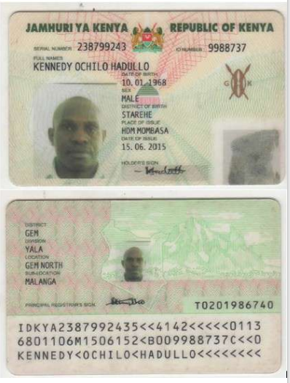

* + 1. PHD CERT

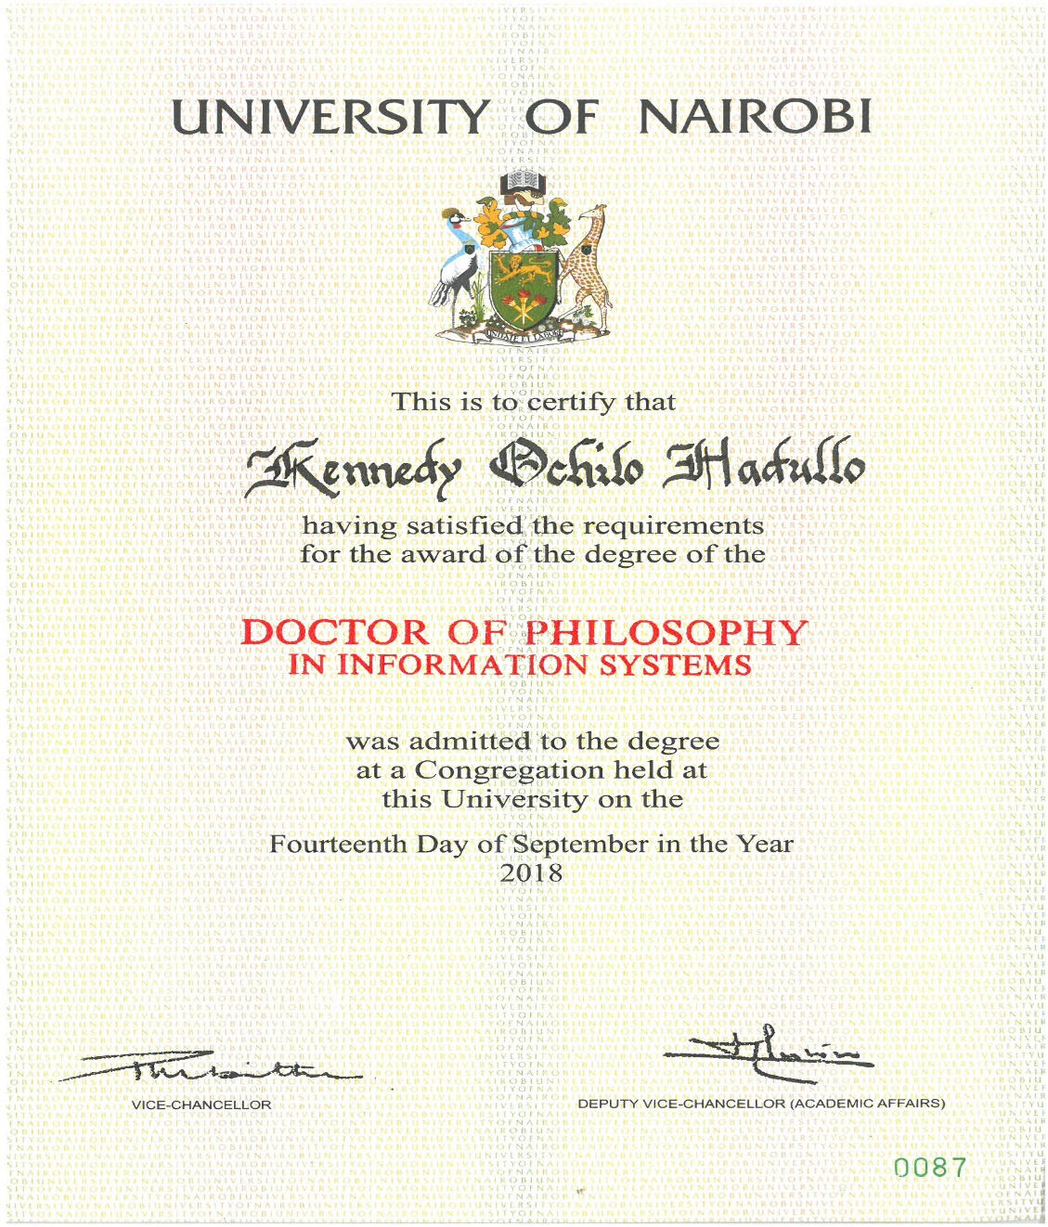

* + 1. MSC CERT

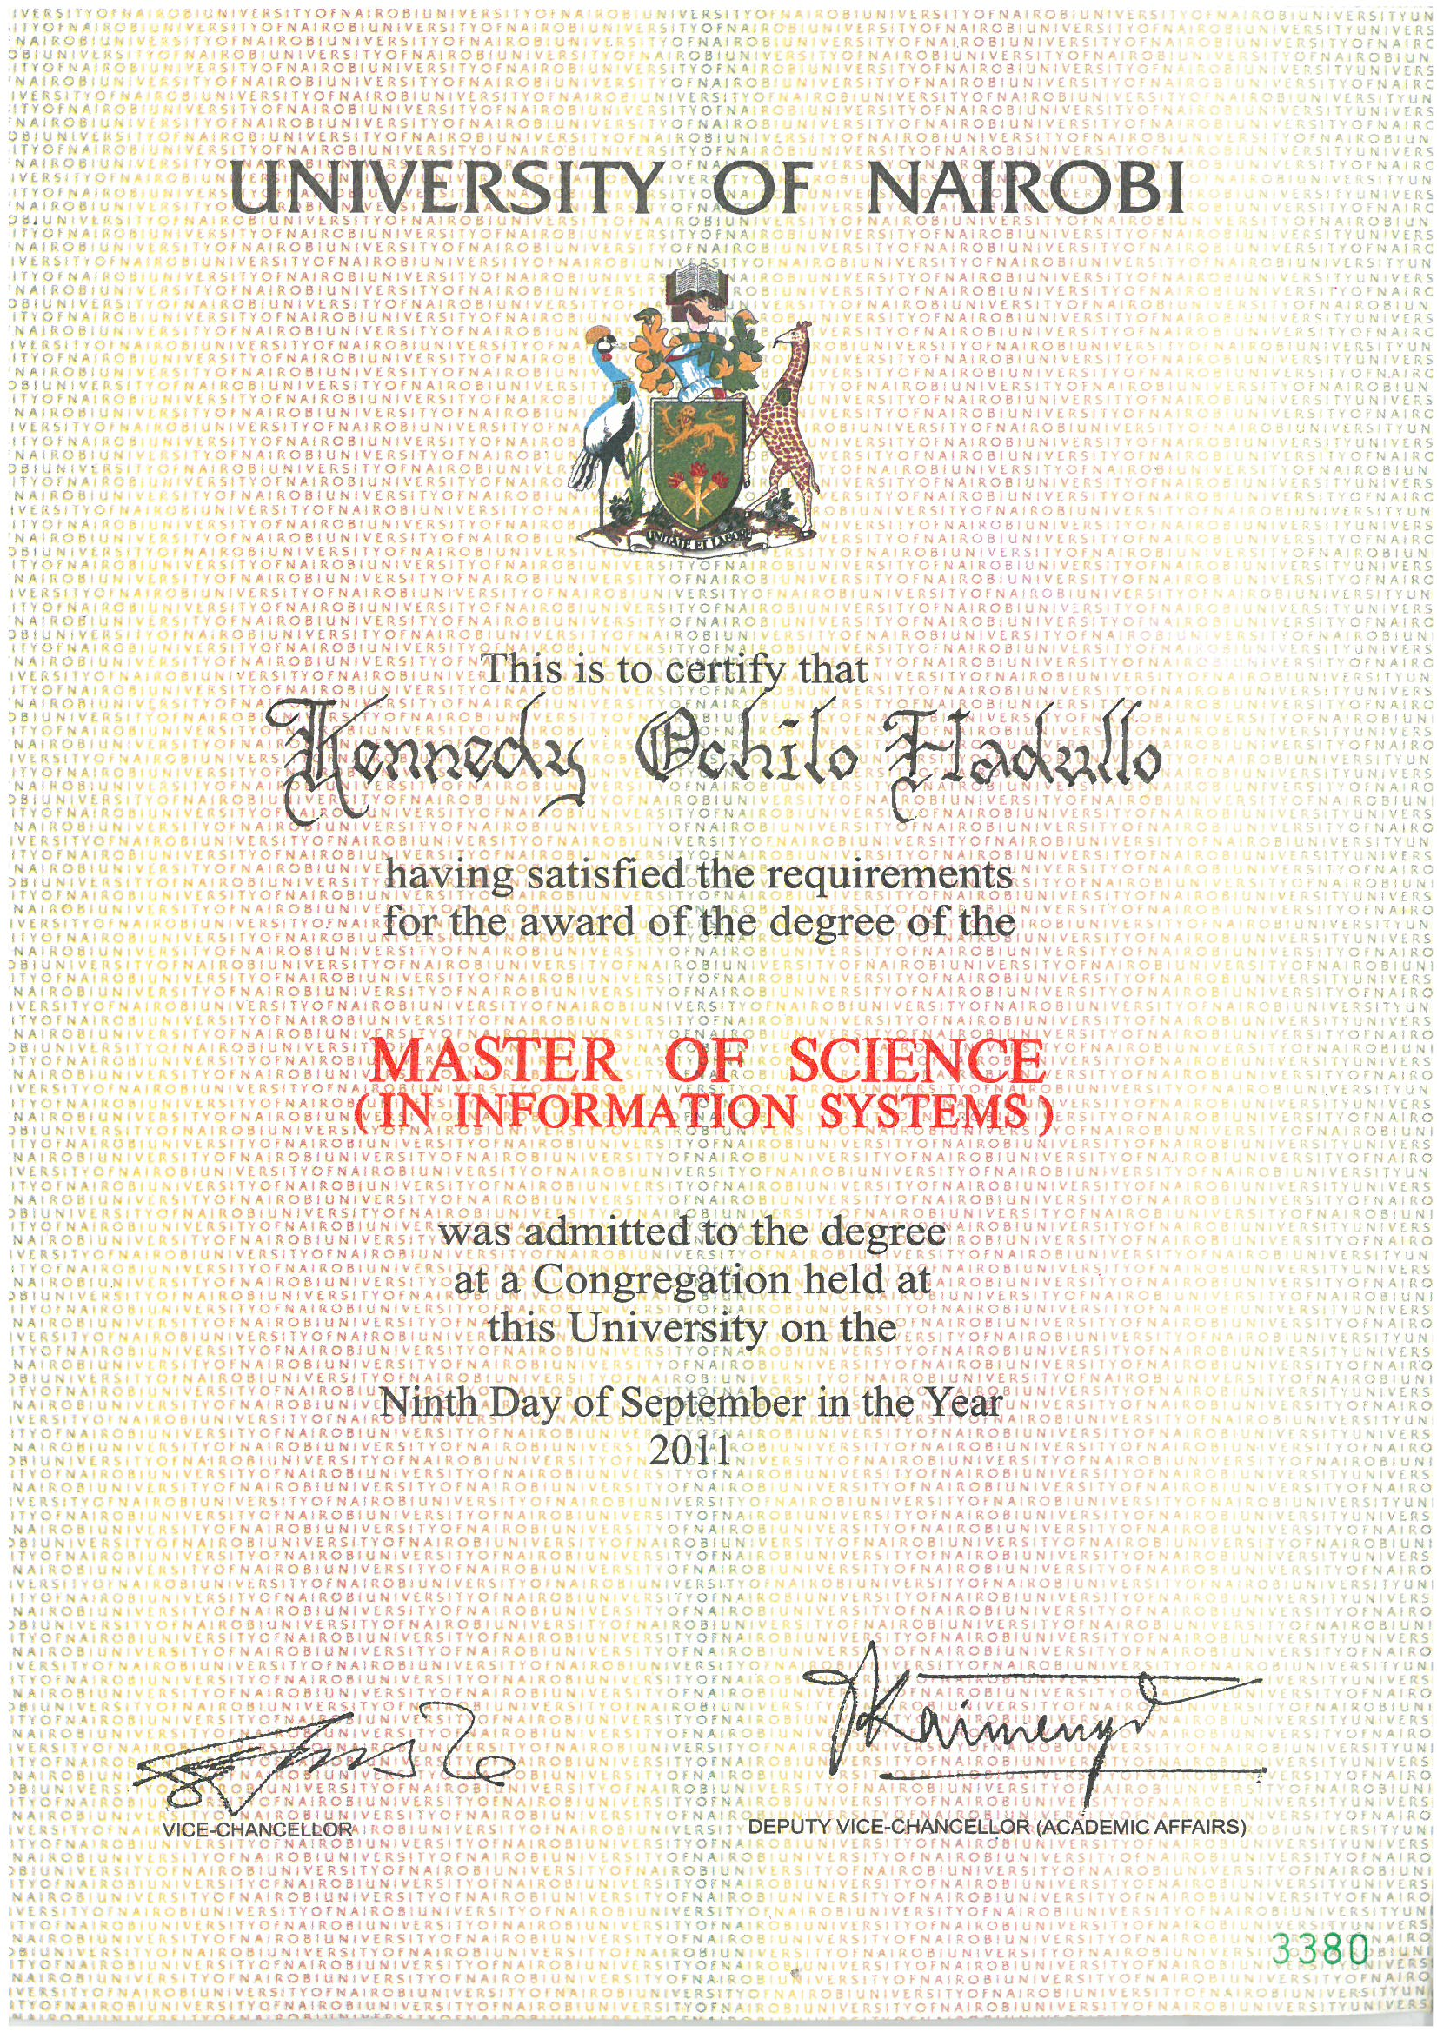

* + 1. BED TECH CERT

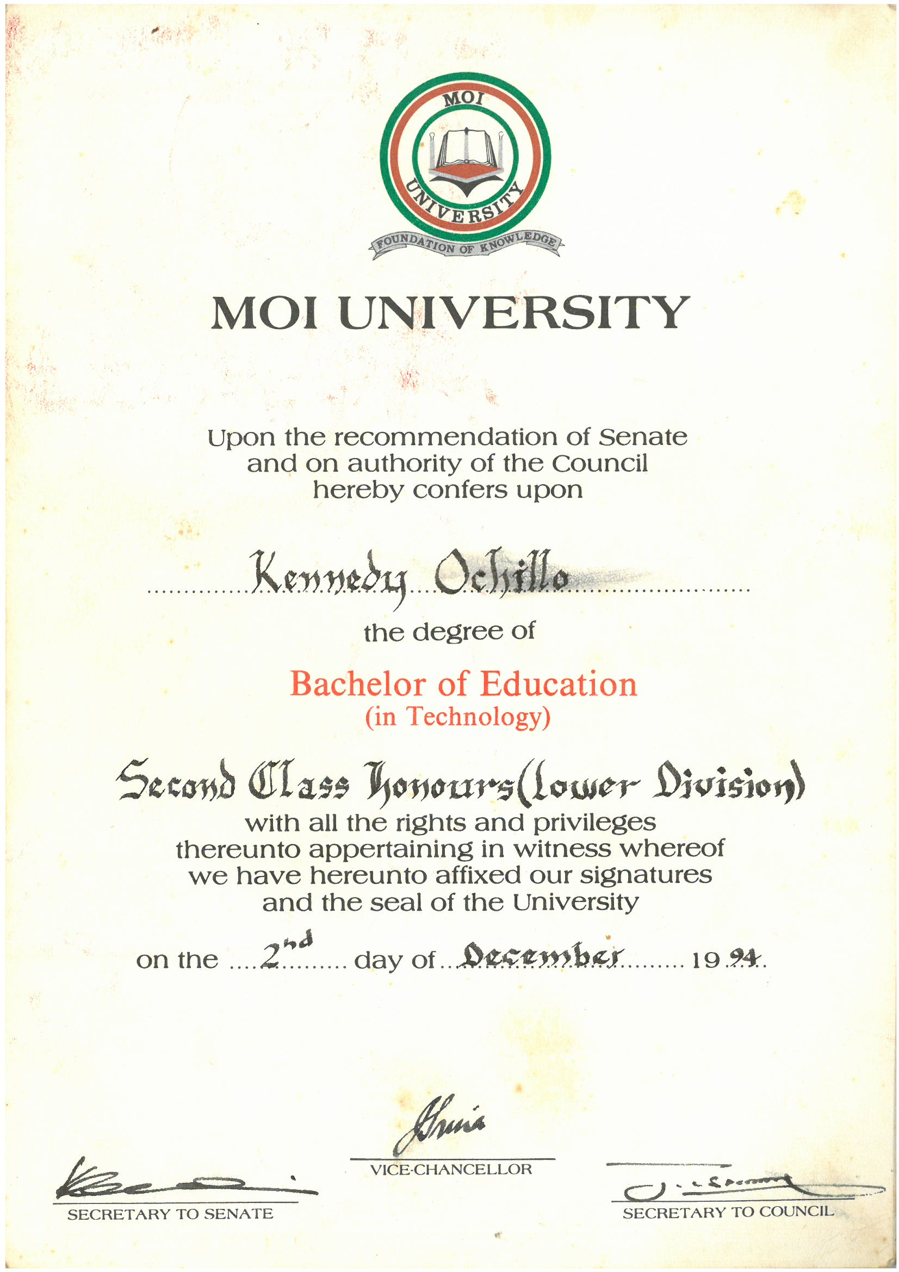

* + 1. CERT A-LEVEL

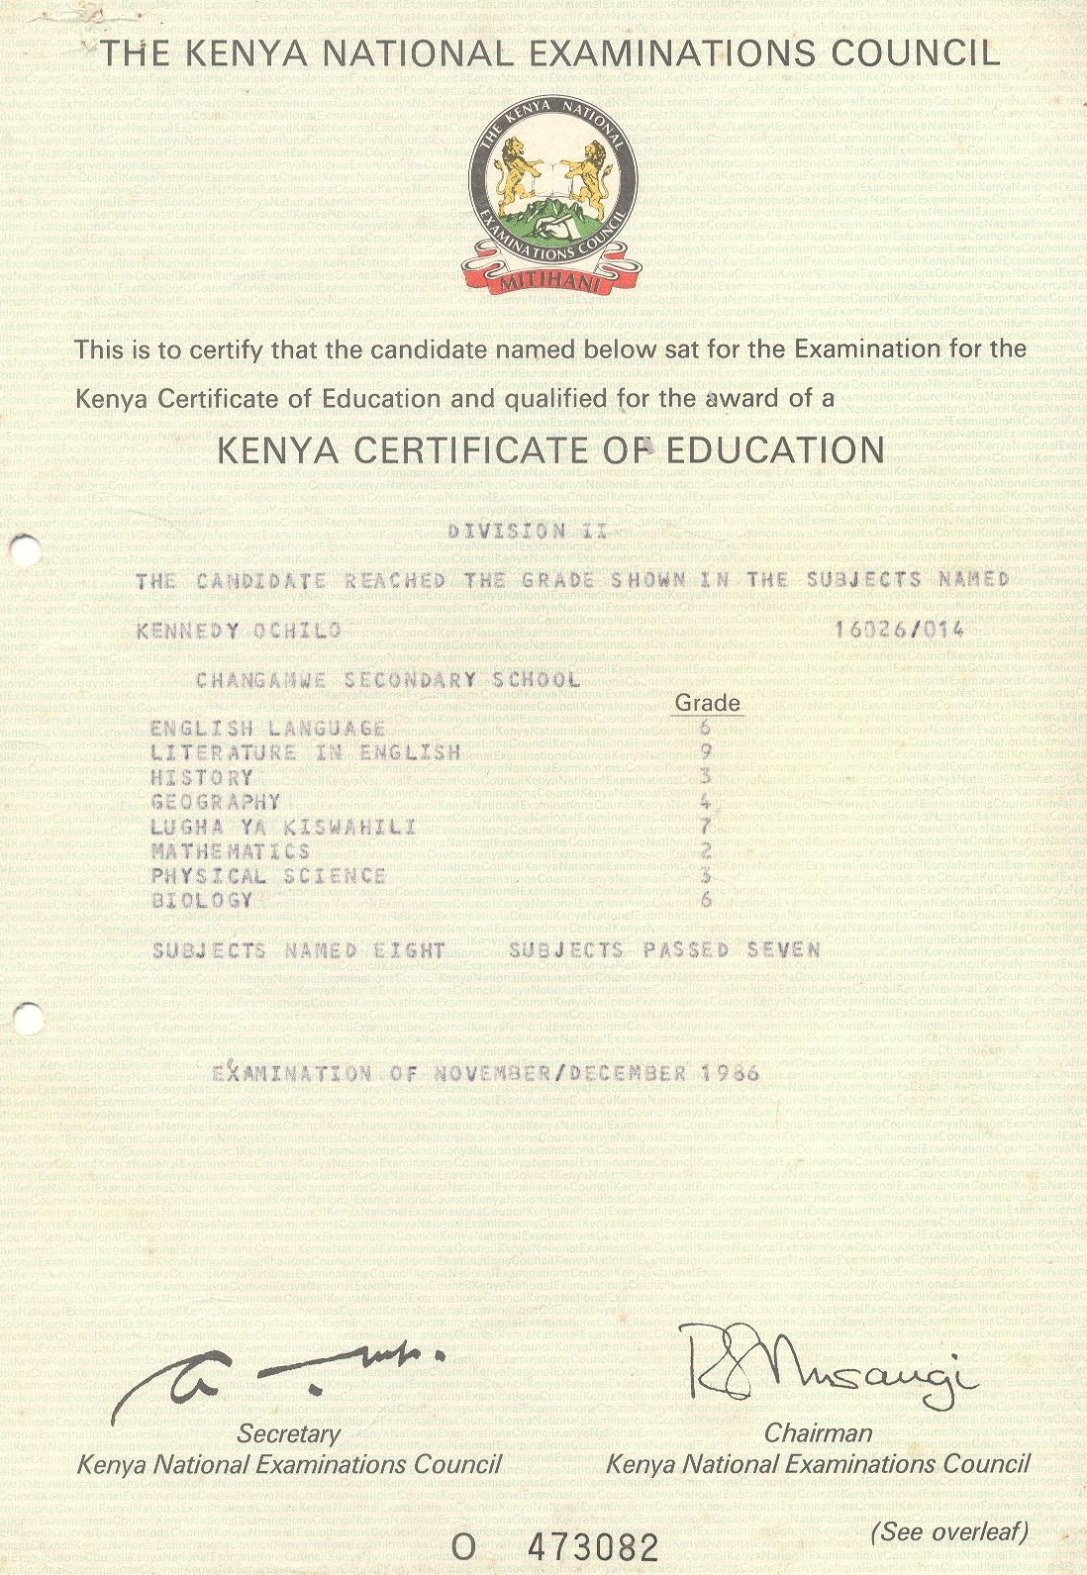

* + 1. CERT O-LEVEL

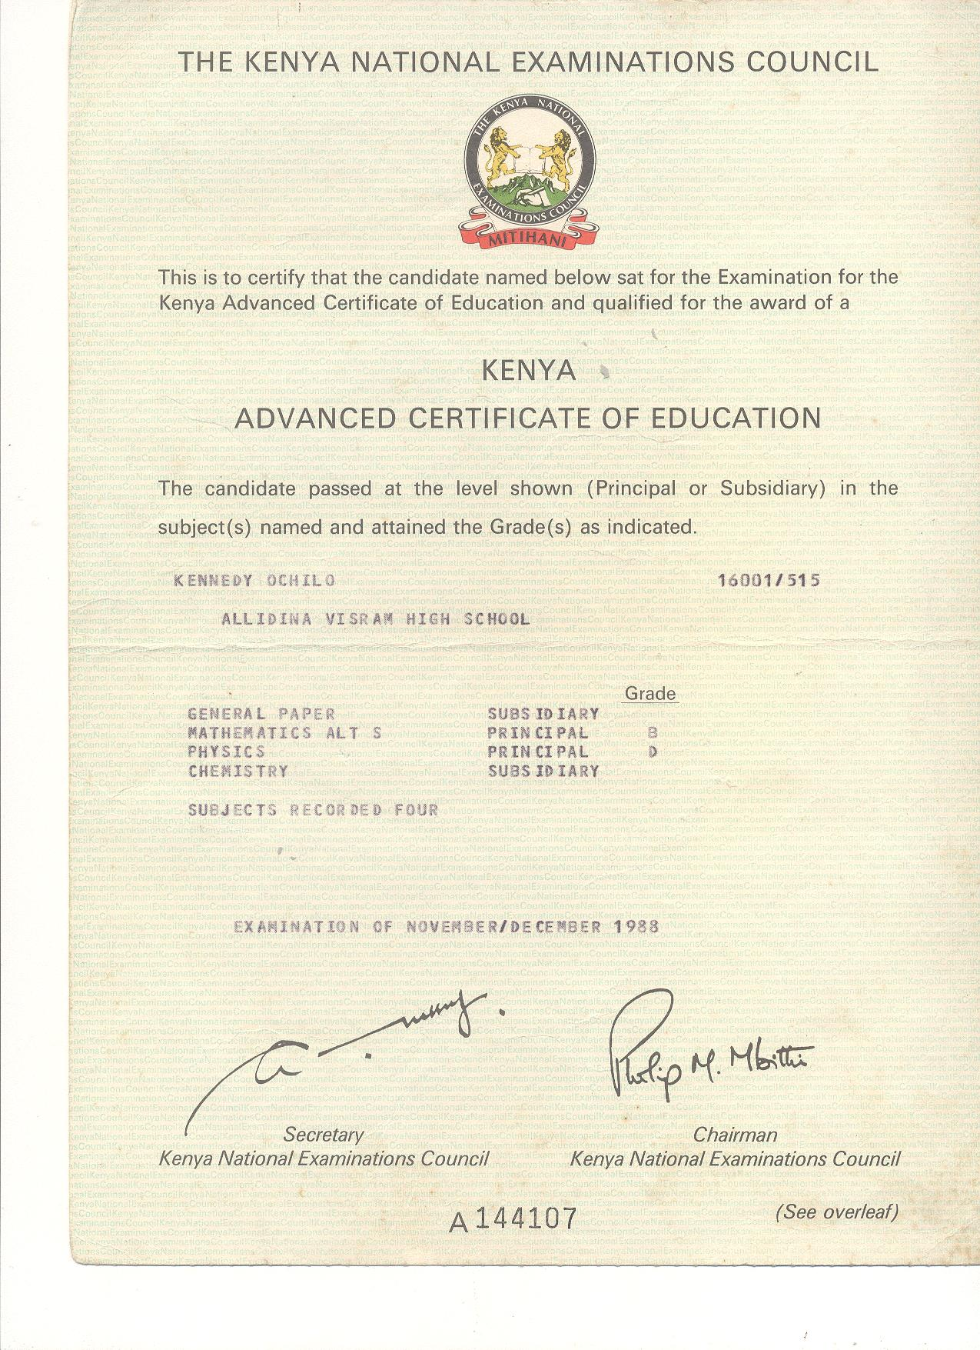

* + 1. OPEN UNIVERSITY OF KENYA CONTENT CREATION LETTER

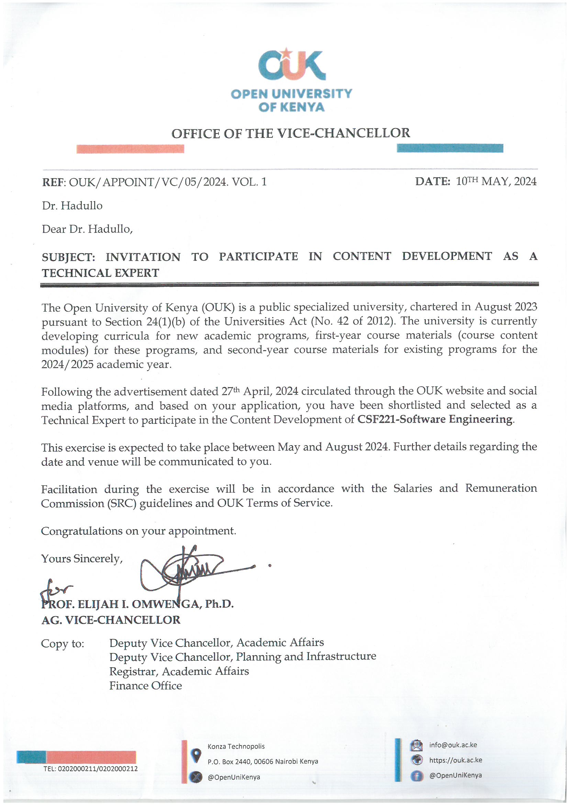

* + 1. KENYA SCHOOL OF GOVERNMENT LETTER

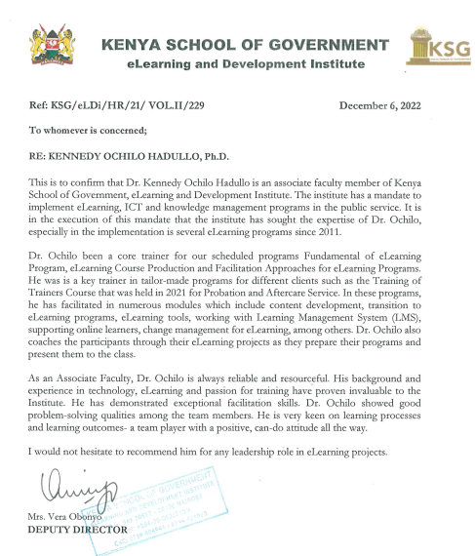

* + 1. SKILLS FOR PROSPERITY TRAINING CERTS

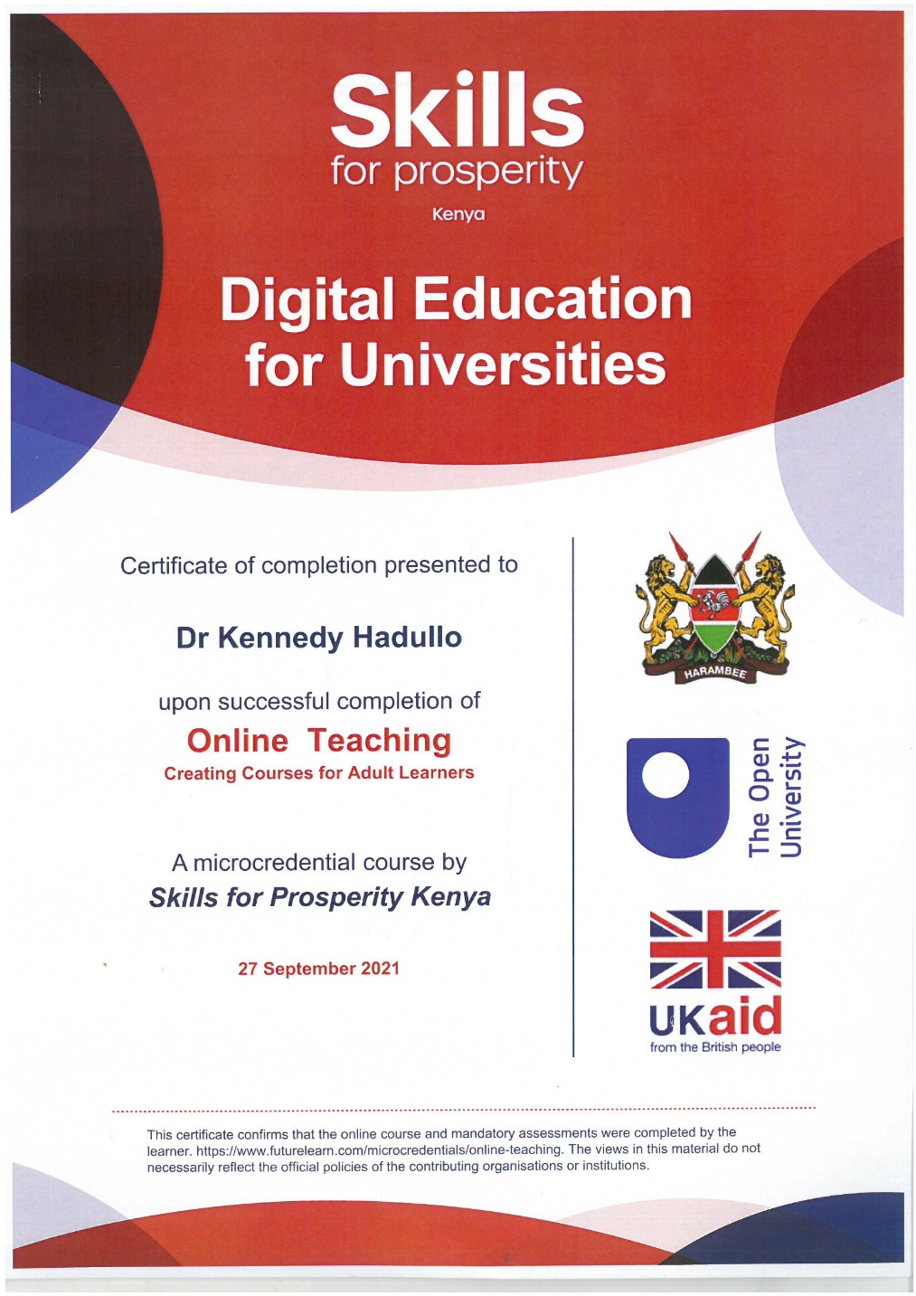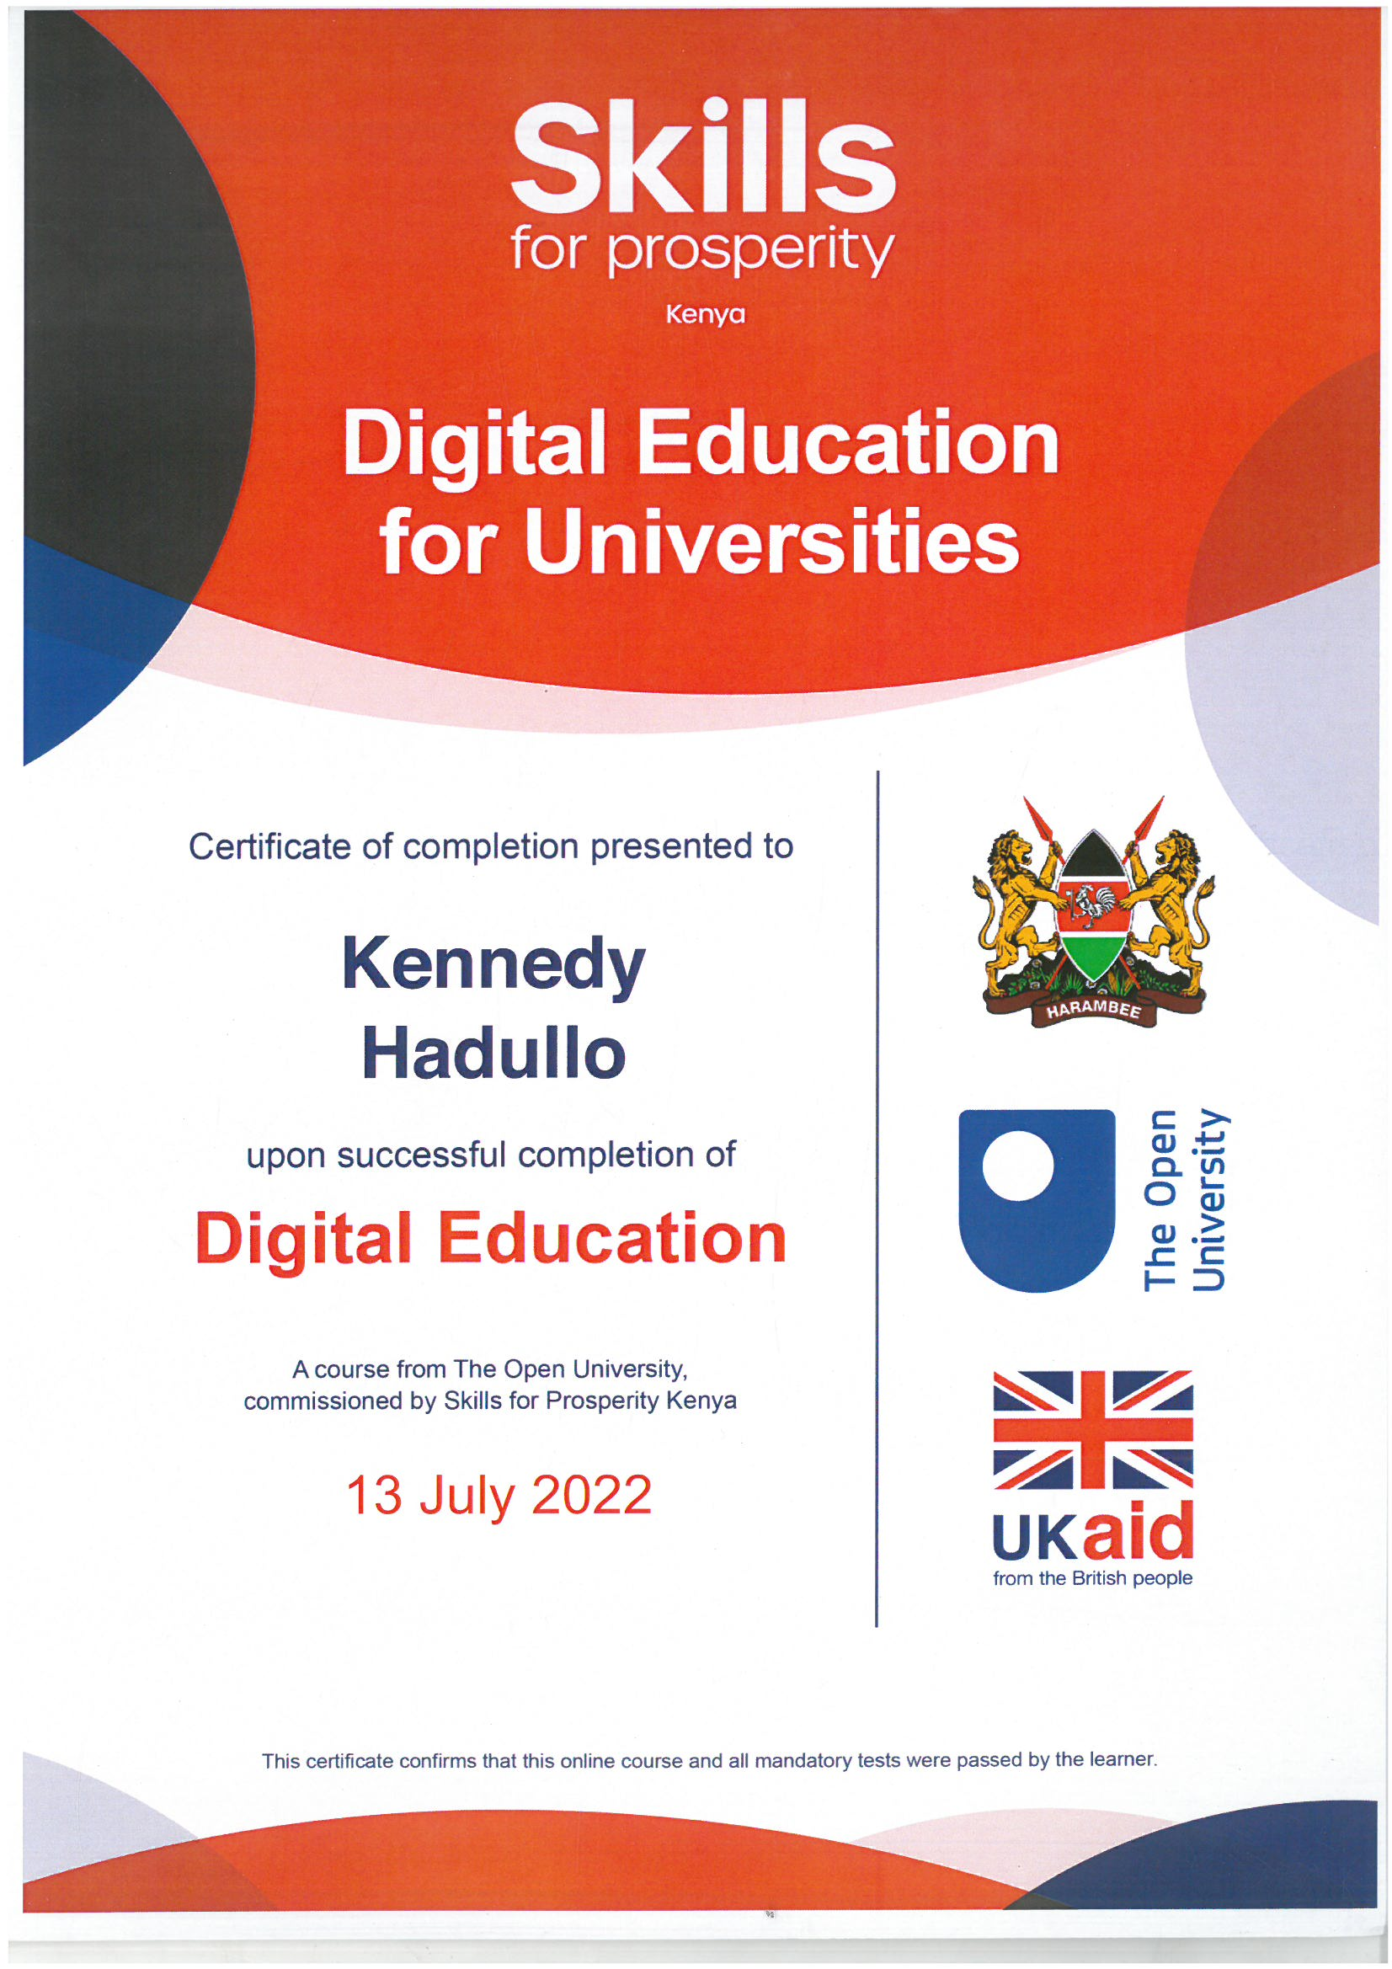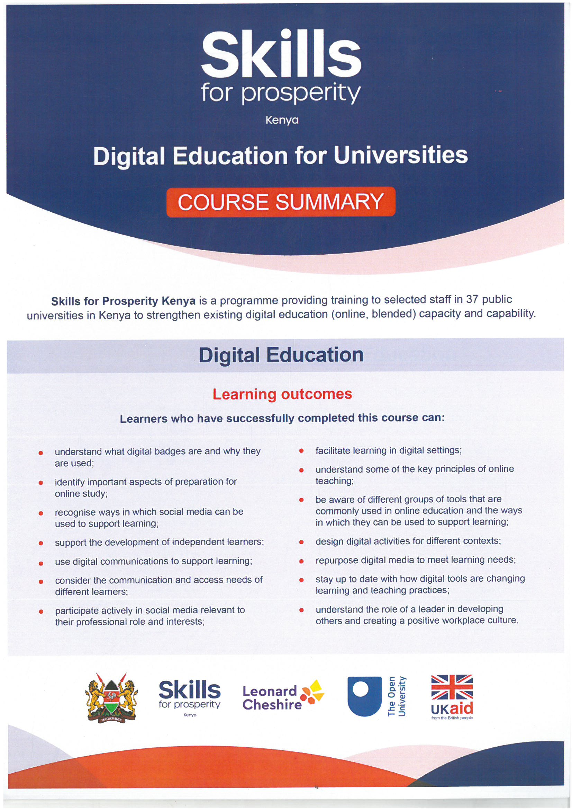

* + 1. ODEL IMPLEMENATATION COMMITTEE LETTER

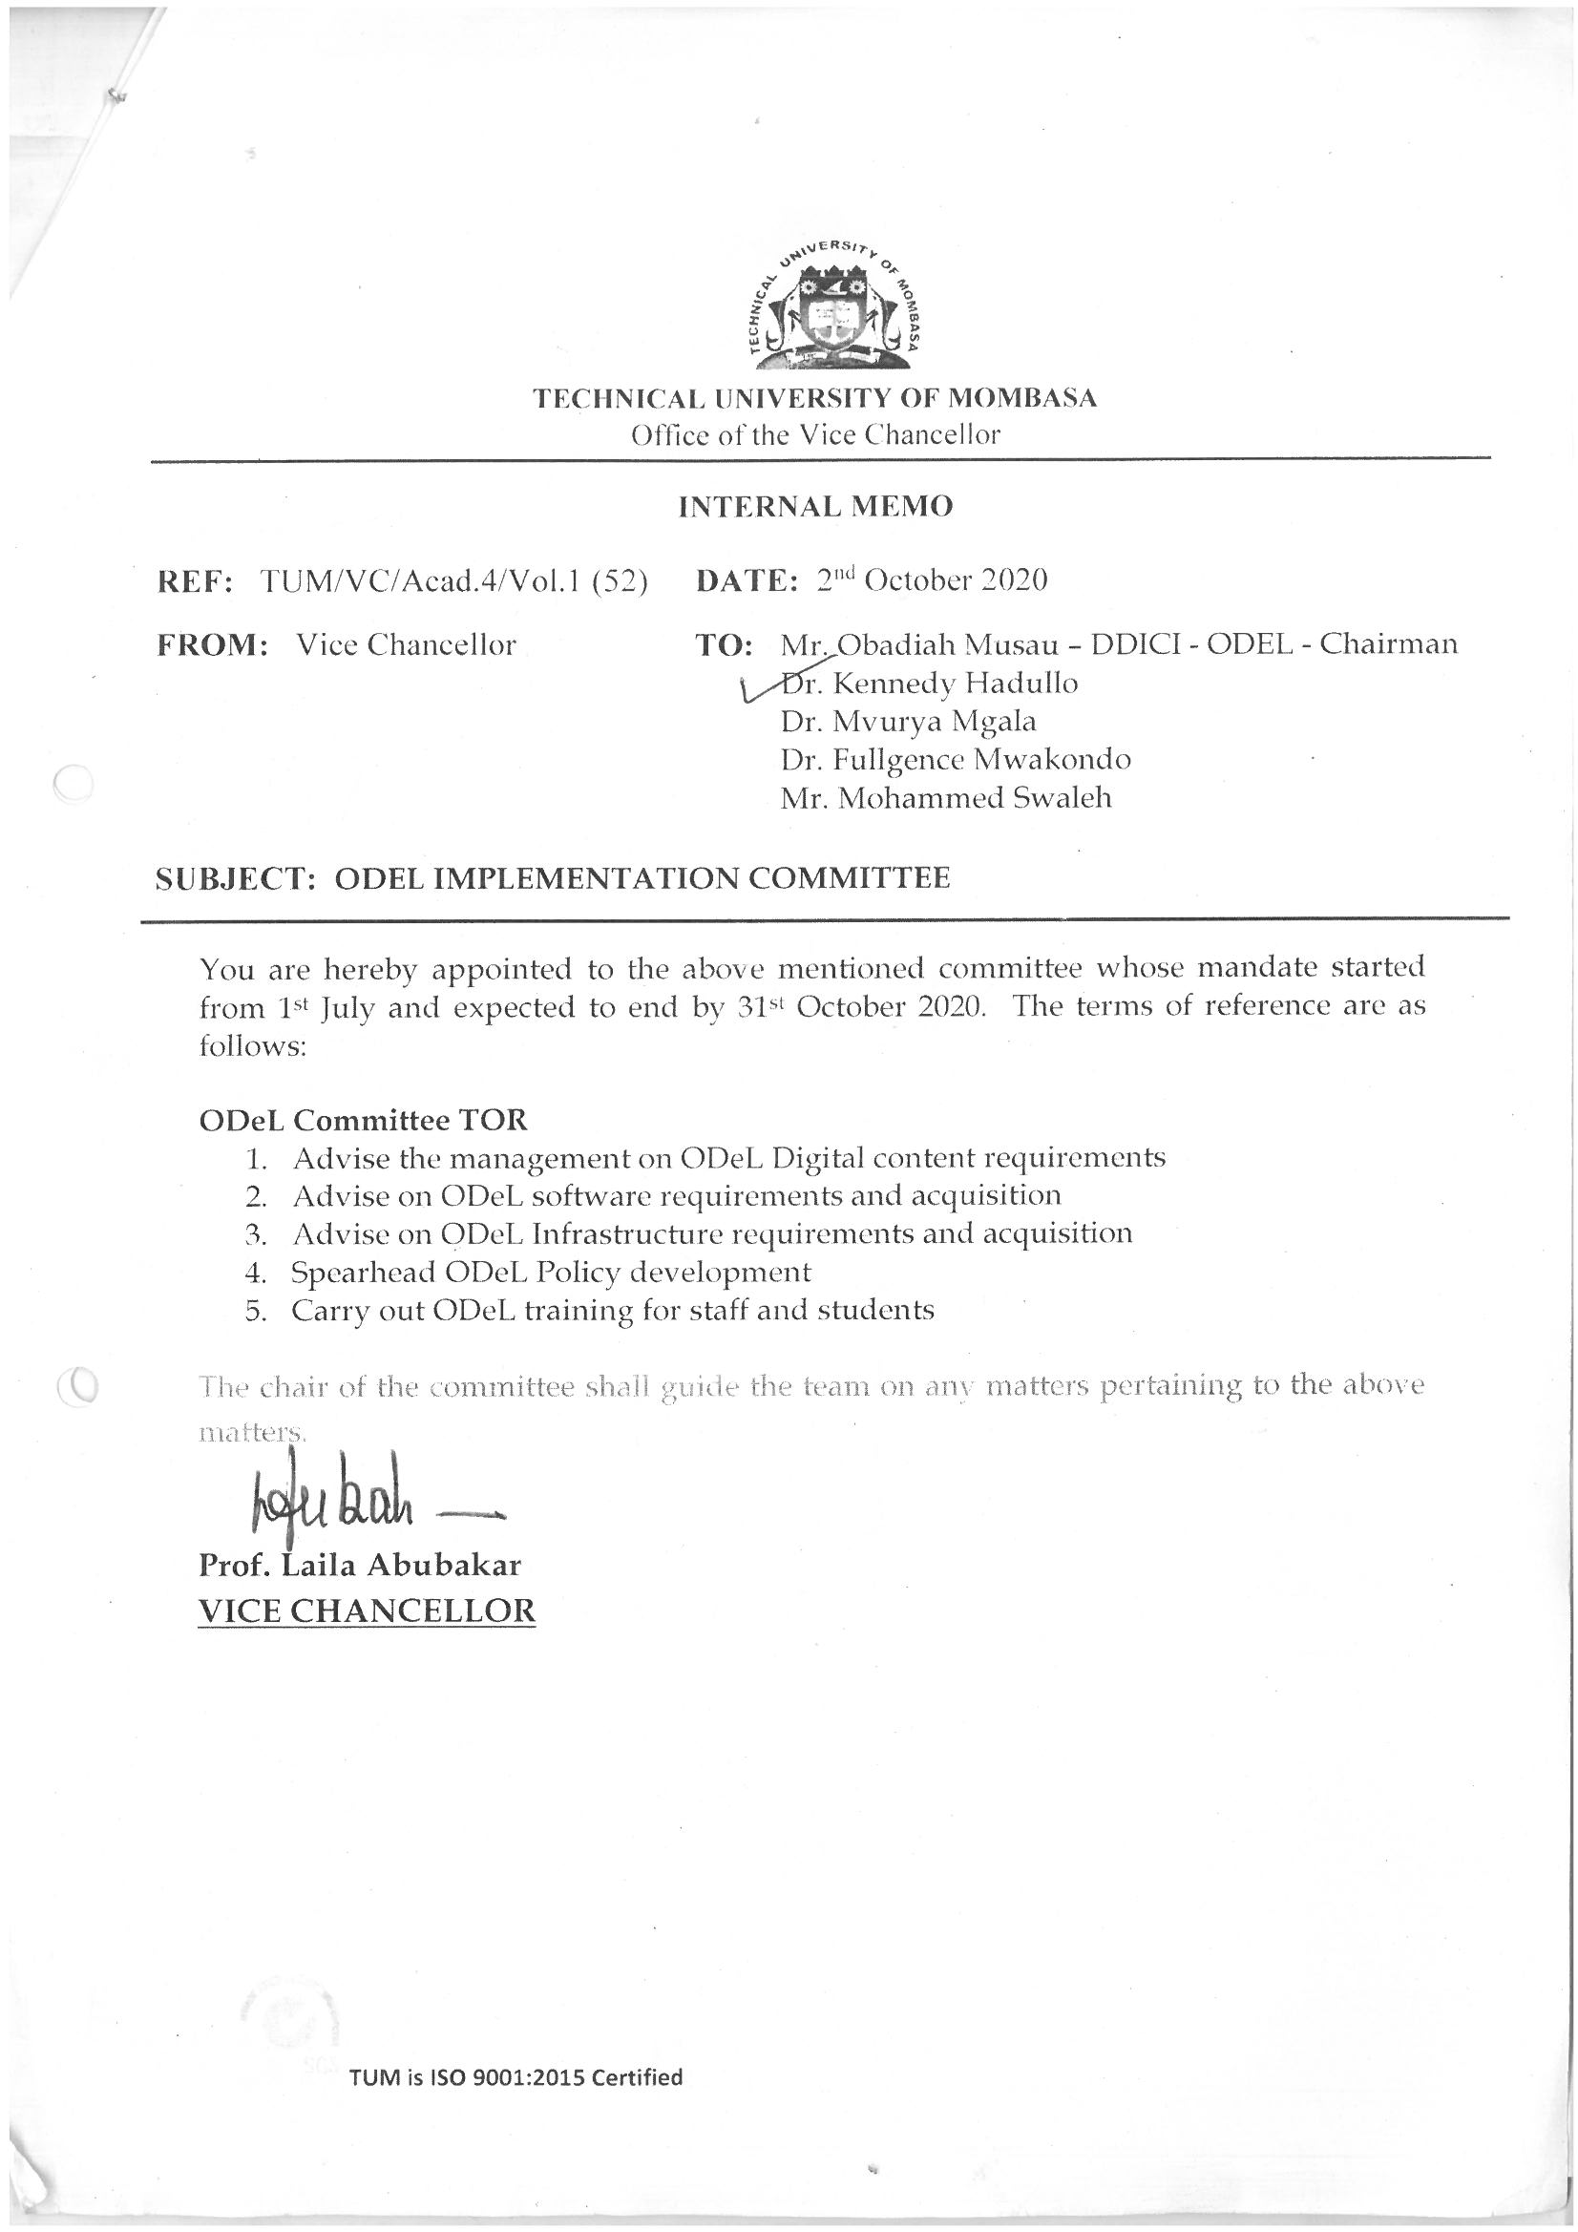

* + 1. SOFTWARE DEVELOPMENT COMITEE LETTER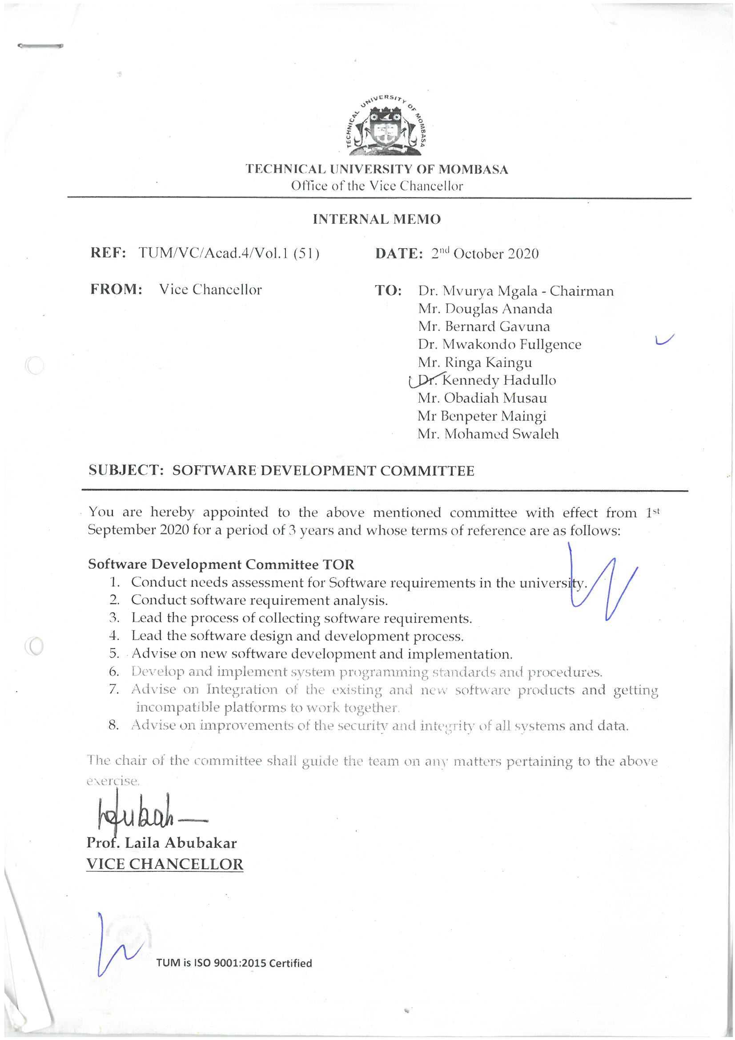
    2. COMPUTER SOCIETY OF KENYA CERT

